EXPERIMENT: 5
OBJECTIVE: Design the LAN(Local Area Network) in Cisco Packet Tracer.

SOFTWARE USED: Cisco Packet Tracer.

THEORY:

LAN stands for Local Area Network.
It is a network that connects computers and devices within a small area such as a home, school, office, or building.
In a LAN, computers are connected using cables (Ethernet) or wireless (Wi-Fi).
LAN allows users to share resources like files, printers, internet connection, and applications.
It usually has high data transfer speed compared to larger networks.
LAN is privately owned and managed by an organization or individual.
Common devices used in LAN include switches, routers, network cables, and computers.
Star topology is the most commonly used topology in LAN networks.
LAN networks are cheaper to set up and maintain compared to WAN.
Example: Computer network in a school computer lab or office.

CODE: Not applicable

PROCEDURE:

1.Collect required devices such as computers, switch/hub, router, and Ethernet cables.
2.Connect the switch or hub to a power source.
3.Connect all computers to the switch/hub using Ethernet cables.
4.Connect the router to the switch if internet access is needed.
5.Assign IP addresses to each computer (automatically by DHCP or manually).
6.Configure network settings on each computer.
7.Check the network connection to ensure all computers can communicate with each other.
8.Test resource sharing such as files, printers, or internet.

RESULTS:

Level | Block Diagram | Running Simulation | Analysis (Command Prompt)
Low | Refer 1.a | Refer 1.b | Refer 1.c
Medium | Refer 2.a | Refer 2.b | Refer 2.c
High | Refer 3.a | Refer 3.b | Refer 3.c

.

Figure 1.a

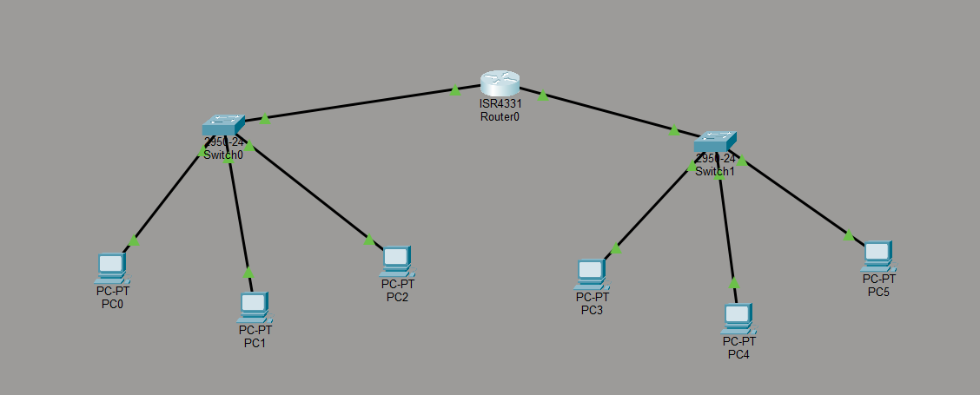

Figure 1.b

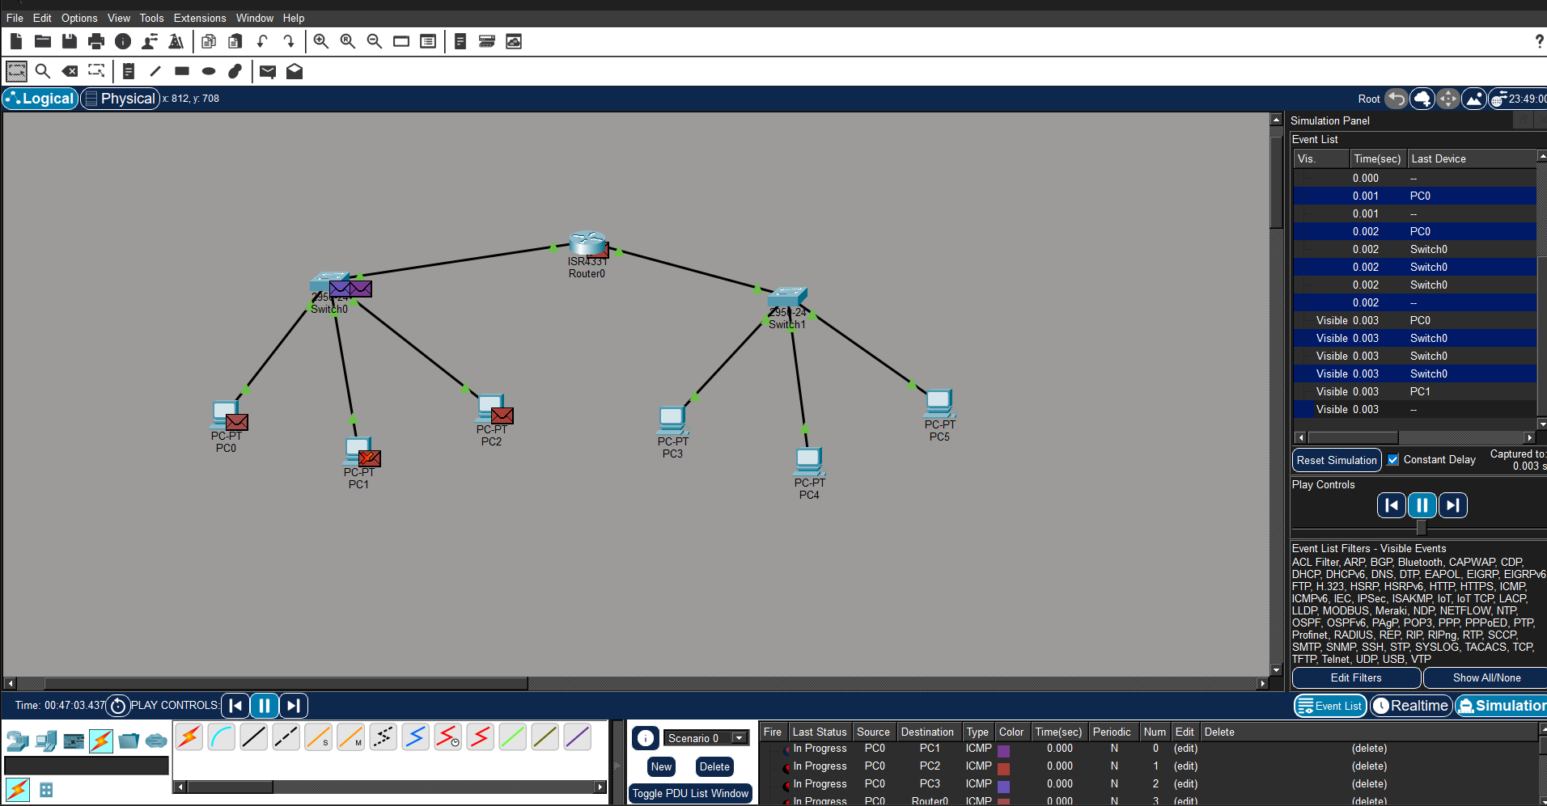

Figure 1.c

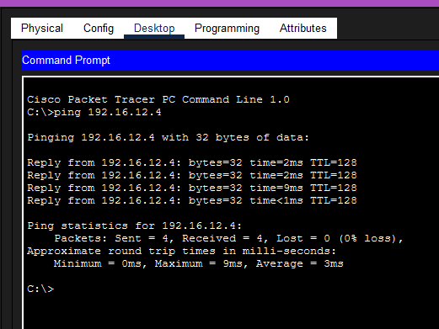

Figure 2.a
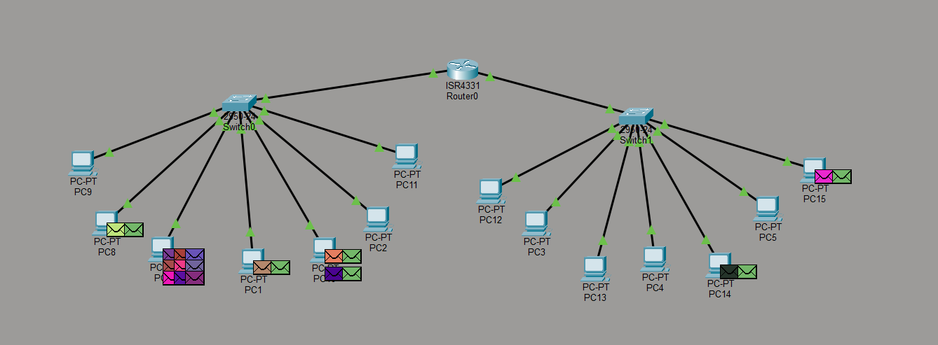

Figure 2.b

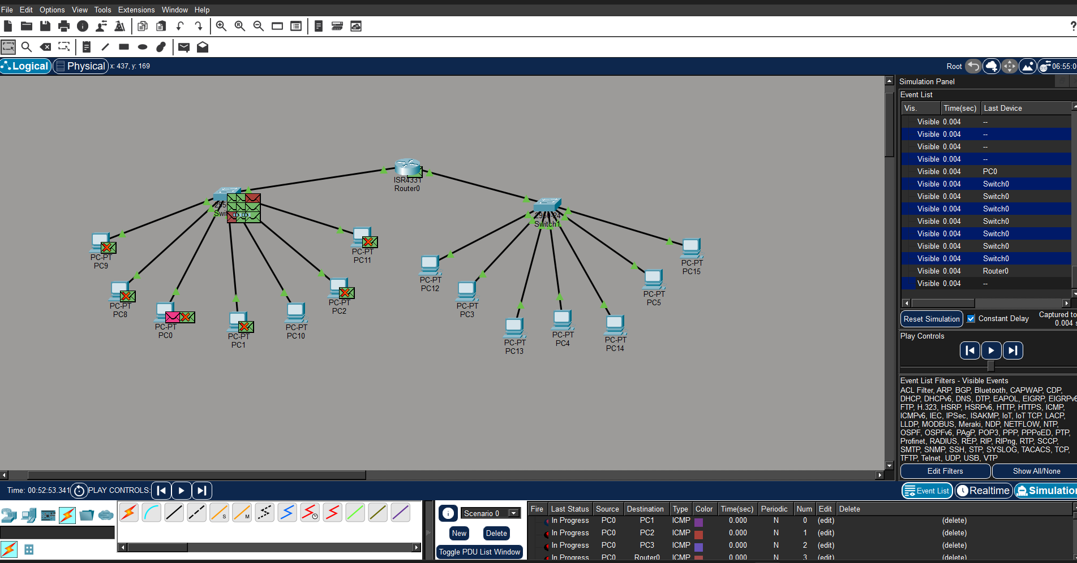

Figure 2.c
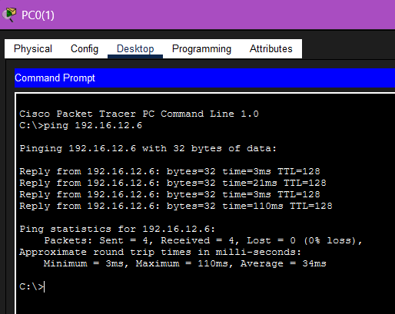

Figure 3.a
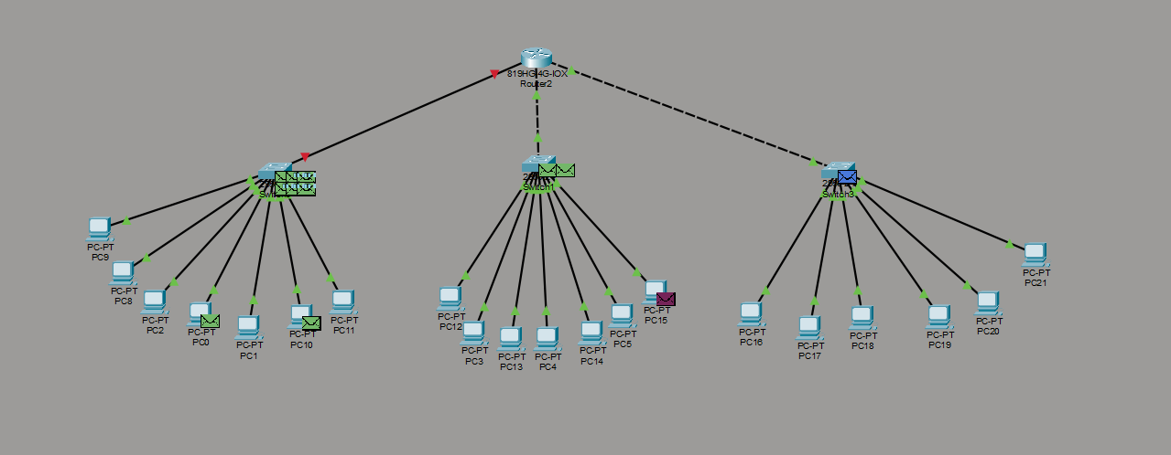

Figure 3.b

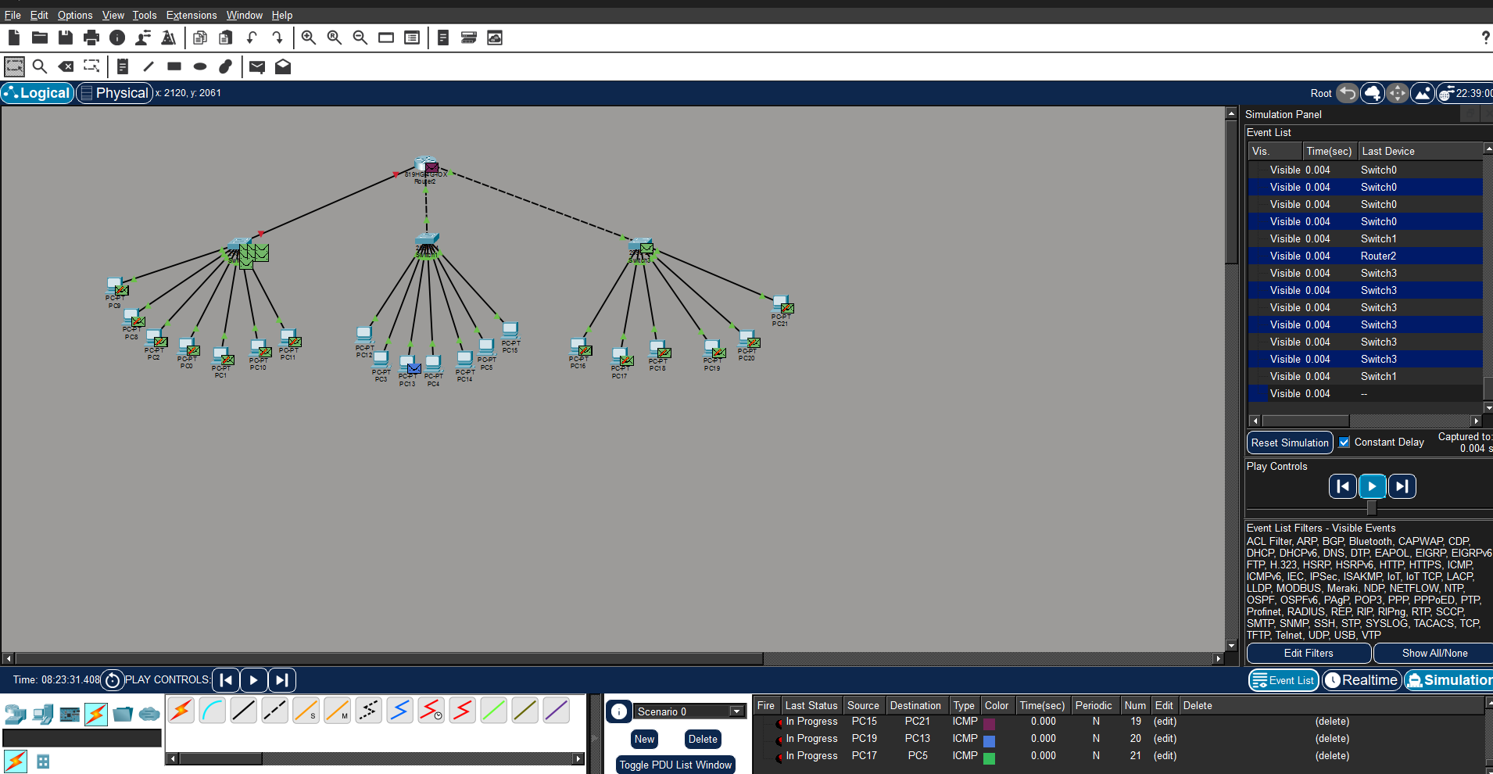

Figure 3.c

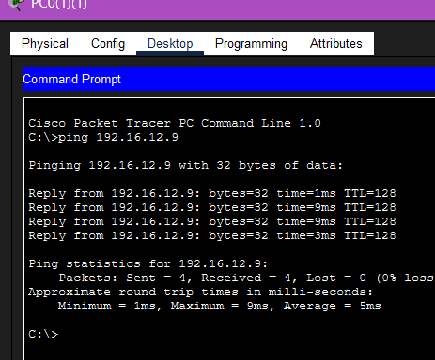

POSSIBLE SOURCES OF ERRORS:

- If the IP addresses on the PCs are entered incorrectly, the devices may not be able to communicate with each other.
- Using the wrong type of cable or making loose/incorrect connections between switches and PCs can cause network failure.
- If the simulation mode is not selected properly or packets are not captured correctly in Cisco Packet Tracer, the data transfer may not be displayed as expected.

CONCLUSION:

In conclusion, LAN (Local Area Network) is a network that connects multiple computers and devices within a limited area such as a home, school, or office. It allows users to share resources like files, printers, and internet connections easily and quickly. LAN is cost-effective, reliable, and provides high-speed communication, making it widely used in organizations and institutions.

PRECAUTIONS:
1. Make sure that every device has a unique IP address and all IPs belong to the same network range.
2. Always use the correct Fast Ethernet cables when connecting PCs and switches.
3. Check all device connections and configuration settings carefully before starting the simulation.

LEARNING OUTCOMES:
- Understood the concept and working of hybrid topology in computer networks.
- Learned how to design and simulate a hybrid network using Cisco Packet Tracer.
- Gained hands-on experience in connecting network devices and assigning IP addresses.
- Learned to test network connectivity using simulation mode and ping command.
- Understood the importance of fault tolerance and reliability in network communication.

